Appendix 8

Burgess Hill Town Market Proposal

Introduction

Burgess Hill is a well-connected place to live with a population of 30,635. In the next 5-10 years the town will see significant growth and investment with an

additional c.4000 homes. Burgess Hill is a priority town for Mid Sussex District

Council’s current housing allocation, associated transport links, fibre broadband improvements and town centre redevelopment proposed from NewRiver REIT.

Planning applications are anticipated from NewRiver REIT for the town centre redevelopment but it is likely due to economic forecasts that we will not see tangible building developments for at least 18-24 months, if at all - with further consideration given to the impact of the current Covid-19 pandemic. It is commonly understood that as more people choose to shop online, the high street is becoming a destination to socialise, browse and shop for unusual or more sustainable/local products rather than a pure or standard shopping

destination. As part of the town council’s strategy to improve trading

opportunities and attract footfall for existing traders by revitalising the town

centre, we have established a working group to reintroduce an open air market to Burgess Hill to fill these gaps in our town’s shopping experience and bring more people to the town. The market viability will be assessed after 6 months to determine successes and reassess risks and performance (see page 5).

Executive Summary

Markets have always been an important part of town centres. In many respects they anchor or are the focus point of town centres across the country. Burgess Hill Town Council have agreed (within the 2020/21 budget) in principle to revive the town centre by introducing a low risk ‘town market’ initiative in-house. After model research (see Appendix D, pg. 15), consultation with NMTF (National Market Traders Federation) and discussion at Strategic KAG, we are now in a position to present our case for introducing a new market for Burgess Hill.

The second Saturday in the month has been chosen due to the gap in the month amongst existing markets in the locality. With that in mind, we are proposing to begin with the first market held on the 12th September and then continue every month, on the second Saturday. With consideration given to the Covid-19 pandemic, we are mindful that risks are somewhat higher for

September 2020 at the time of writing, but that contingency and risk planning (see pg.11) have taken these issues into account.

We are planning to make a small surplus of income in the first year of £1000 and a surplus of £2960 in the second year. (See cost analysis on pg.4).

1. BUSINESS / INDUSTRY OVERVIEW
Town markets can be successful ways of driving footfall, boosting trade for existing shops and play a significant part in the social and cultural life of a town. Local jobs, product sourcing and spending keep money in the local economy rather than national chain stores. Burgess Hill market aims to retain existing customers and maintain perceptions of good value, whilst attracting new customers and make a surplus after costs. The market focus will be on family-friendliness and environmental sustainability featuring staple favourites and niche markets for specialist stalls, charity and events based on popular local activities.

2. product / service offering
The market focus will be on family friendly stall selection and environmental sustainability. We aim to feature at least 20 stalls on one Saturday per month featuring staple favourites such as bread, cheese and fish, and niche specialist stalls, charity/community and events or entertainment based on popular local activities or groups.

3. Challenges
- Lack of footfall, vitality and buzz as the town is in development
- No diverse shopping in the town, with more opportunities offered by neighbouring towns
- Current transitional phase awaiting development application from NRR
- No local produce, or waste free options currently
- Shoppers are looking for greater social interaction whilst cost and VFM are expectations that must be met

4. solutionS
- Create a family friendly destination with sustainable or low waste stalls for the whole family
- Local produce that is not offered in existing shops - with low food miles, preferably produced less than 30 miles from Burgess Hill
- More variety and entertainment for residents and visitors offered, that other towns do not

5. unique value proposition
A destination for the whole family – ‘Mid Sussex Family Friendly Market’ in Burgess Hill
Currently there is no other market on 2nd Saturday in the month within a 20 miles radius.
Good public transport links to the town.

This working group extensively researched 4 other successful markets (See Appendix D, pg.15) to establish successful models of town markets, price points, timings and other proven attributes that can enhance the town market in Burgess Hill. After consolation with NMTF and looking at existing models we can establish that a minimum of 20 stalls would provide enough variety, appeal and authenticity to provide a great shopping experience within Church Walk, Burgess Hill. (See Appendix A. pg. 10)

6. customer segments
Observations below are based on the 2011 census. Note that Burgess Hill Town will be
expanding with c.4000 dwellings in the next 5-10 years with revised boundary lines with
Ansty yet to be determined,

Target: ABC, Older families who are socialising, browsing, seeking a more experiential shopping visit with the added attraction of entertainment, local music… Shoppers seeking locally sourced produce and sustainable goods, generating less waste.

Burgess Hill has 20% more higher and Intermediate managerial, administrative or professional households than the national average.

The population of Burgess Hill as a whole, is older than the national average. However, the population of Burgess Hill is younger than the West Sussex average.

The rate of unemployment in Burgess Hill is both lower than the average for West Sussex and lower than the national average, suggesting that finding a job in this area maybe easier than most places. The rate of claiming any benefit (which includes in work benefits) is more than 10% lower in Burgess Hill than the national average, suggesting higher salaries than the average in the area.

(Source: https://www.ilivehere.co.uk)

7. channels to reach TARGET customer
- The town centre/ physical market
- Digital and printed advertising
- Town centre notice boards, banners
- Advertorial, local press
- Market traders and existing shops

8. cost structure

Agreed BHTC Expenditure Budget in year 1 for Town Market: £3000 (Bridge The Gap)

Year 1
Income: £4000
- 20 x traders at £20 per month (maximum two meter stall) over 10 months = £4000 (first two markets are free to incentivise traders to join). Larger size stalls charged at £20 increments.
Expenditure: £3000
- Annual Market License = up to £400 p/a
- 1 x BHTC Staff on Market Day, per month x 12 = up to £1200 p/a
- Marketing/promotion spend per year = £1000 p/a
- Contingency = £200 p/a
- Covid-19 signage or hand sanitiser = £200 p/a
Surplus = £1000
Year 2
Income: £5760
- 24 x traders at £24 per month (maximum two meter stall) over 10 months = £5760 (first two markets are free to incentivise traders to join). Larger size stalls charged at £24 increments.
Expenditure: £2800
- Annual Market License = up to £400 p/a
- 1 x BHTC Staff on Market Day, per month x 12 = up to £1200 p/a
- Marketing/promotion spend per year = £800 p/a
- Contingency = £200 p/a
- Covid-19 signage or hand sanitiser = £200 p/a
Surplus = £2960

8.1 Financial Notes

The market will be operated by Burgess Hill Town council. The market will be reviewed at 6 months (March 2021) to assess performance, financial viability and to reassess risk. Expenditure had already been earmarked from the ‘Bridge The Gap’ budget 2020/21 from which these costs of £3000 (year 1) have been allocated.

9. key Performance metrics
ACTIVITY | DESCRIPTION | PERFORMANCE METRIC
Impact on existing traders | Income and customer response/experience questionnaire | Questionnaire scores
Footfall | Monitoring visitors each month on market day compared to non-market Saturdays | Number of people
Experience | Customer feedback | Verbal feedback and questionnaire scores
Income/Expenditure | Income and Expenditure within budget | Minimum £1000 surplus

10. TIMELINE
ACTIVITY | DESCRIPTION | START DATE | END DATE
Council Approval | Agreed by full council at BHTC | 15.6.20 | 22.6.20
Stalls shortlisted | Identify minimum of 30 relevant stalls for the market with the objective of securing a minimum of 20 for the first market in September | 4.6.20 | 31.7.20
Stalls confirmed | 20 stalls booked for at least first 6 months of open market | 4.6.20 | 31.7.20
Confirm license with MSDC and temporary Road Closure (WSCC) | Agree terms and cost for license with MSDC | 4.6.20 | 30.6.20
Marketing Plan/Spend | Finalise costings and plan promotional spend for first 12 months of market | 22.6.20 | 31.7.20
Begin marketing and promotion | Launch open market and announce date with press release | 1.8.20 | Ongoing
Finalise trader  application form and T&Cs | Agree all details and made available to download on BHTC website or available in paper copy for potential traders | 4.6.20 | 30.6.20
Covid-19 Monitoring | Continue to review government guidelines for operating a market and ensure traders are aware of requirements | 4.6.20 | Ongoing
First Market Day | Market is live | 12.9.20 | Ongoing

11. Marketing MIX
Activity | Date | Cost
Social Media | BHTC Facebook/Twitter  Create Market Events  Boost event to reach a larger audience (Emily researching options/costs)  Burgess Hill Uncovered  Whats on guides | Tbc
Radio | - Burgess Hill Radio  - Mid Sussex Hospital Radio  - More Radio  - Heart Radio | Tbc
Print | - About Town  - Press Releases  - Posters on Town Council noticeboards  - Sussex Living Magazine, plus other similar publications  - Advert page  - Editorial  - Diary Dates  - Mid Sussex Times  - National Market Traders Federation publication?  - Mid Sussex Matters  - WSCC Connections  - BHBPA Newsletter  - Neighbouring Parish/Town Councils (HPP, Hassocks, Ditchling, Cuckfield, Lindfield, Chailey, HHTC  - Bus Companies | Tbc
Banners | Vertical banners attached to lighting columns in Queen Elizabeth Avenue.  Banners around the town  McDonalds Roundabout railings, St John’s Park railings, Market Place Shopping Centre, on balcony above walkway | Tbc  Cost per banner (design and installation) NB. There are 9 banner locations but we don’t have to use all of them.

11.1 Marketing Strategy (TBC)
Activity | Cost | Date From | Date To | Outcome

12. SWOT Analysis

Strengths | Opportunities
Excellent officers at BHTC | Increase trade for existing ‘fixed’ shops
Existing and robust distribution channels to promote the | Engage with community groups and charities
Adequate budget to develop the concept and promote widely | Raise profile of Burgess Hill to wider district
Full support from all town councillors to go ahead with a town market in principle | Unique family friendly shopping experience
Backing from Mid Sussex District Council | Entertainment and greater experiential possibilities than existing markets
Excellent transport connections with planned development for greater cycling connections in the town | No other town markets operating on second Tuesday in the month in Mid Sussex
Weakness | Threats
Public doubt that Town Centre will be redeveloped within next 2 years by NRR | Increased online shopping channels
Reputation of town to ‘pick up a bargain’, rather than a unique shopping experience | Lack of customer demand
Could take 6 months to become established | Existing established town markets in surrounding towns
Risks of incremental weather impacting footfall in first 6 months | COVID-19 restrictions may impact on logistics and shopper experience
 | Existing shops resistant to new market

13. Licenses, permissions and insurance

MSDC -
WSCC -
Insurance -

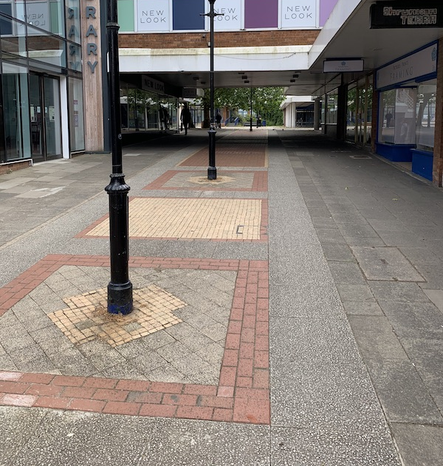
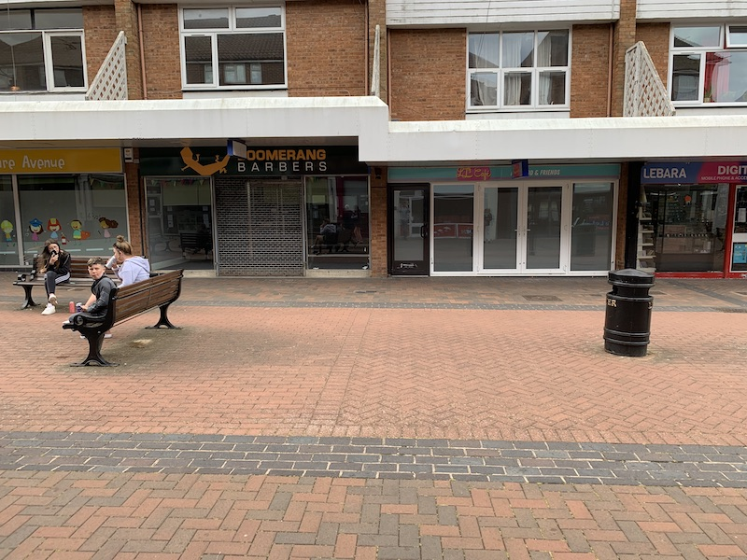
Appendix a: market Stall Plan

Stall site

Stall site

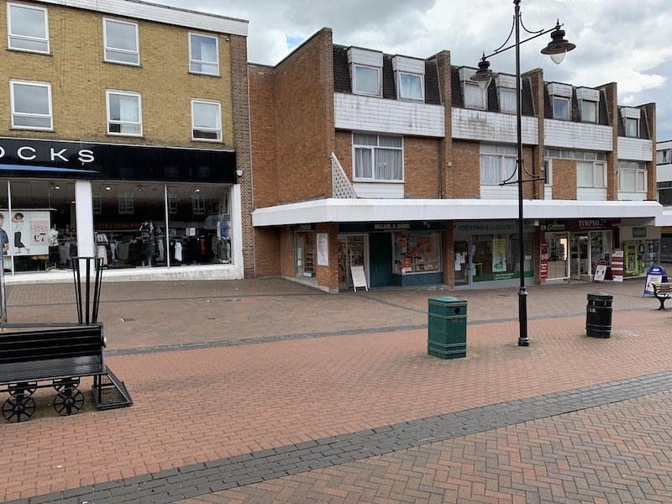
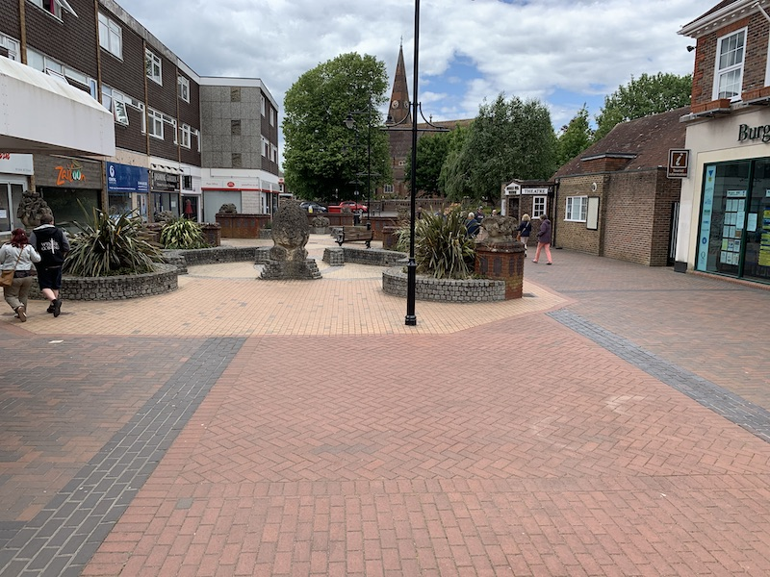
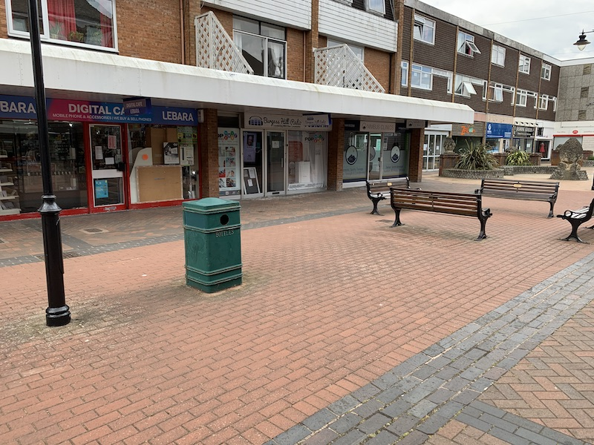

Stall site

Stall site

Stall site

Site Logistics and Operations

Operational notes: Market Day (TBC)

- Arrival on site
- Applications and T&Cs
- Management
- Refuse collection and removal
- Payment terms

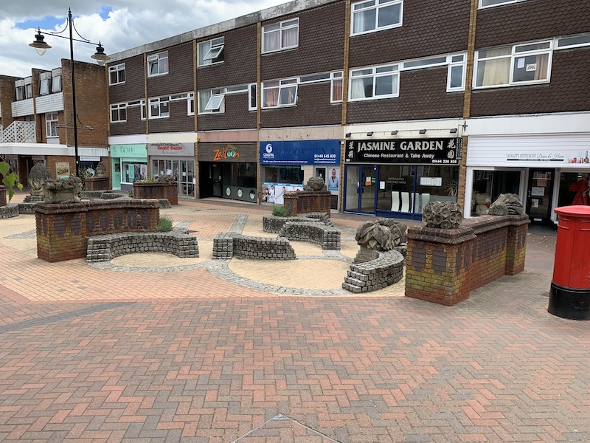

Stall site

Appendix B: Market Site Map - Burgess Hill Town Centre

TBC

Appendix C: Risk Assessment

TBC

Appendix D: Market Research
Town Market Comparison Table - BHTC 17.5.20
Market | Times | Operating Days | Cost | Pitch Size | Application Links | Traders Directory? | Other
Stroud | 9am-2pm | Every  Saturday | £40.00 | n/a | https://fresh-n-local.co.uk/wp-content/uploads/2020/03/Application-Pack2020.pdf | Y | Certified by FARMA (National Farm Retail & Market Assoc). Initial £50 fee to cover admin costs.
Lewes | 9am-1pm | 1st and 3rd Saturday of the Month | £28.00 | 3mx3m | http://www.commoncause.org.uk/new-page-1 | Y | Established for over 22 years. Run by Common Cause. 30 mile radius limit of local produce permitted to be on sale.
South Kesteven | 8.30 am - 4pm | Saturdays (and Fridays in  different towns) | Day Charge £31 2/3Day Event £47 Weekly Charge £84 Monthly Charge £135 Annual Charge £382 | Stall 3.05m x 1.22m, Pitch 3.05m x 3.05m | Various depending on type of stall and Regular or Casual | Y | Stalls are built for the traders but covers are required by traders. Traders MUST belong to NMFT. Trade waste is removed.
Lymington | 8am - 4pm | Every Saturday | Casual is £10 1 May - 30 Sept and £5 1 Oct - 30 Apr plus £2.25 per foot. Permanent pay for 48 weeks, paid at £86.25 per month (No Premium of £10) | 10ft | http://www.lymingtonmarket.co.uk/the-market/trading | Y | Over 100+ stalls. Plus: Friday night market 6pm-8pm!

